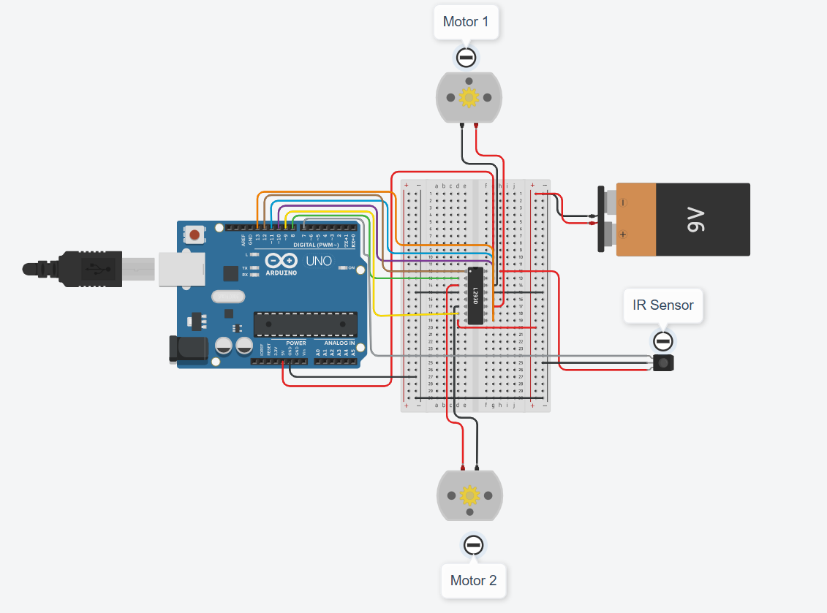

Figure 1: Line Following Robot

// --- Line Following Robot Code – Part 01 ---
// IR Sensors
const int irLeft = 2;
const int irRight = 3;
// L298N Motor Control
const int enA = 9;
const int in1 = 5;
const int in2 = 6;
const int in3 = 7;
const int in4 = 8;
const int enB = 10;

int speed = 150;

void setup() {
pinMode(irLeft, INPUT);
pinMode(irRight, INPUT);

pinMode(enA, OUTPUT);
pinMode(in1, OUTPUT);
pinMode(in2, OUTPUT);
pinMode(in3, OUTPUT);
pinMode(in4, OUTPUT);
pinMode(enB, OUTPUT);

analogWrite(enA, speed);
analogWrite(enB, speed);
}

Expt No:  04 | LINE FOLLOWING ROBOT
Date:
/ /2025

AIM:
To construct and program a 2WD autonomous robot capable of detecting and following a black line on a white surface using a pair of IR (Infrared) sensors.

APPARATUS REQUIRED:
- Microcontroller: Arduino UNO R3,
- Chassis: 2WD Robot Chassis with 2 DC Motors,
- Motor Driver: L298N Motor Driver Module,
- Sensors: 2x IR Proximity Sensor Modules,
- Power: Battery Pack (e.g., 9V or 7.4V Li-Ion),
- Software: Arduino IDE,
- Components: Jumper Wires, Mini Breadboard,
- Miscellaneous: Black electrical tape (for line), White surface (e.g., chart paper).

THEORY:
The line follower operates using a differential drive system where the speed of two motors is controlled independently. Two IR sensors are mounted at the front, one on the left and one on the right, positioned to straddle the line. The IR sensor works on the principle of reflectivity. The white surface reflects the emitted IR light, which is detected by the sensor (typically outputting a LOW signal). The black line absorbs the IR light, resulting in no reflection (outputting a HIGH signal).

The control logic is as follows:
- Both Sensors on White (LOW, LOW): The robot is on the line. Move forward.
- Left Sensor on Black (HIGH, LOW): The robot has veered to the right. Turn left.
- Right Sensor on Black (LOW, HIGH): The robot has veered to the left. Turn right.
- Both Sensors on Black (HIGH, HIGH): Stop or reverse (optional, indicates an intersection or end).

PROCEDURE:

- Connections:
- IR Left (OUT) → Arduino Digital Pin 2,
- IR Right (OUT) → Arduino Digital Pin 3,
- L298N IN1 → Arduino Digital Pin 5,
- L298N IN2 → Arduino Digital Pin 6,
- L298N IN3 → Arduino Digital Pin 7,
- L298N IN4 → Arduino Digital Pin 8,
- L298N ENA (Left Speed) → Arduino PWM Pin 9,
- L298N ENB (Right Speed) → Arduino PWM Pin 10,
- Connect Motors to L298N OUT1/OUT2 (Left) and OUT3/OUT4 (Right),
- Connect L298N +9V to Battery (+),
- Connect L298N GND to Battery (-) AND Arduino GND (Common Ground),
- Connect L298N +5V to Arduino 5V (if jumper is in place),
- Connect IR Sensors VCC/GND to Arduino 5V/GND.

- Code: Upload the following sketch to the Arduino.

// --- Line Following Robot Code – Part 02 ---
void loop() {
int leftState = digitalRead(irLeft);
int rightState = digitalRead(irRight);

// Move based on sensor states
if (leftState == LOW && rightState == LOW) {
moveForward();
}

else if (leftState == HIGH && rightState == LOW) {
turnLeft();
}

else if (leftState == LOW && rightState == HIGH) {
turnRight();
}

else if (leftState == HIGH && rightState == HIGH) {
moveStop();
}
}

void moveForward() {
digitalWrite(in1, HIGH);
digitalWrite(in2, LOW);
digitalWrite(in3, HIGH);
digitalWrite(in4, LOW);
}

void turnLeft() {
digitalWrite(in1, LOW);
digitalWrite(in2, HIGH);
digitalWrite(in3, HIGH);
digitalWrite(in4, LOW);
}

void turnRight() {
digitalWrite(in1, HIGH);
digitalWrite(in2, LOW);
digitalWrite(in3, LOW);
digitalWrite(in4, HIGH);
}

void moveStop() {
digitalWrite(in1, LOW);
digitalWrite(in2, LOW);
digitalWrite(in3, LOW);
digitalWrite(in4, LOW);
}

- Observation: Create a track using black tape on a white surface. Place the robot so the line is between the two sensors. Power on the robot. Observe how it correctly adjusts its motors to turn left or right when a sensor detects the line, successfully navigating the path.

RESULT AND OBSERVATION:
The 2WD line following robot was successfully constructed and programmed. The experiment validated the use of IR sensors for line detection and the implementation of a state-based control logic to modulate differential drive motor output for autonomous navigation.

